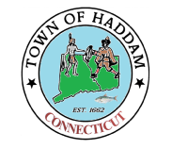
Town of Haddam
Higganum Cove Advisory Committee Agenda
Community Center
7 Candlewood Hill Rd
Thursday – April 11, 2024
6:00 pm

1. Call to Order

2. Public Comment

3. April 20 Cove clean up plan

4. Old Business: Project updates and discussions (lower foundation- need for entrance gate,
mural art, signs)

5. HES/Cove monitor applications: Enzo D’Amico / Michael Jantsch

6. Approval/Correction of the Minutes

7. Adjournment

members: Peter Baird, Susan Horan-Decarli, Tim McCane, Dorothy Gillespie, Ed Schwing, Tim Teran, Dante Ursini

Please note: These meetings are scheduled to be held on the second Thursday of each month.
MEETINGS ARE SUBJECT TO CANCELLATION
AND AGENDAS ARE SUBJECT TO CHANGE

