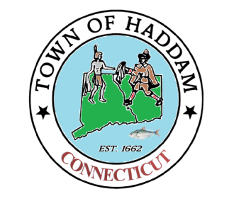
Town of Haddam
Zoning Board of Appeals
Meeting Notice
Town Hall – 21 Field Park Drive
November 30, 2023
7:00p.m.

This meeting is canceled
Next meeting 12.28.23

- Call to order
- Attendance
- Public Hearing:
4. Public Meeting:
5. Approval/corrections of minutes
6. Open discussions
7. Adjourn

